**8 SCIENCE 2014**

### BIOLOGY TEST TWO

Name: ____________________ Teacher: ___________________ Mark: /50

**Percentage: %**

**SECTION A: MULTIPLE CHOICE (15 marks)**

**Select the most correct answer for each question below.**

Please answer on the multiple choice answer grid below.

1. A B C D 10. A B C D

2. A B C D 11. A B C D

3. A B C D 12. A B C D

4. A B C D 13. A B C D

5. A B C D 14. A B C D

6. A B C D 15. A B C D

7. A B C D

8. A B C D

9. A B C D

Questions 1-3 refer to the image on the right.

**1.** Choose the correct statement below.

(a) ‘A’ refers to a guard cell.

(b) ‘A’ refers to a stomata.

(c) ‘A’ refers to chloroplast.

(d) ‘A’ refers to a nucleus.

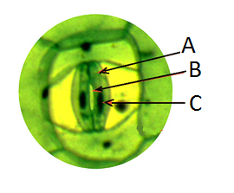

**2.** Choose the correct statement below.

(a) ‘B’ refers to a nucleus.

(b) ‘B’ refers to a guard cell.

(c) ‘B refers to a stomata.

(d) ‘B’ refers to chloroplast.

**3.** Choose the correct statement below.

(a) ‘C’ refers to chloroplast.

(b) ‘C’ refers to a stomata.

(c) ‘C’ refers to a guard cell.

(d) ‘C’ refers to a nucleus.

**4.** Skin is also known as:

(a) epithhydrogen

(b) epithelium.

(c) epithoxygen

(d) epithnitrogen

**5.** Choose the correct definition for ‘bacteria’.

(a) simple unicellular organisms that do not have a nucleus.

(b) simple unicellular organisms that do have a nucleus.

(c) simple multicellular organisms that do not have a nucleus.

(d) complex multicellular organisms that do have a nucleus.

**6.** There are two types of fat cells in your body, they are:

(a) good fat cells and bad fat cells.

(b) large fat cells and small fat cells.

(c) thin fat cells and thick fat cells.

(d) brown fat cells and white fat cells.

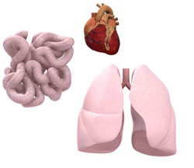**7.** The images on the right are all examples of:

(a) tissues.

(b) organs.

(c) systems.

(d) cells.

**8.** The cells that carry oxygen from the lungs around the body are known as:

(a) white blood cells.

(b) oxygen blood cells.

(c) red blood cells.

(d) energy blood cells.

**9.** Skeletal muscle is also known as:

(a) voluntary muscle.

(b) smooth muscle.

(c) involuntary muscle.

(d) rough muscle.

**10.** The muscles that surround the bones in your body and help you more around are called:

(a) voluntary muscle.

(b) skeletal muscle.

(c) involuntary muscle.

(d) both (a) and (b).

**11.** Choose the correct statement about involuntary muscles.

(a) They work automatically.

(b) The join muscles together.

(c) They help you move around.

(d) They work in pairs.

**12.** The largest organ in the human body is the:

(a) large intestine.

(b) skin.

(c) lungs.

(d) heart.

**Questions 13-15 refer to the diagram on the right.**

**13.** The structures in the diagram are found in:

(a) the roots of plants.

(b) in the flowers of plants.

(c) in the leaves of plants.

(d) in the stem of plants.

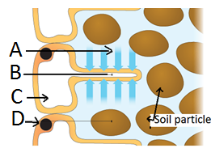

**14.** The diagram is showing:

(a) The structure of conducting cells.

(b) The structure of photosynthetic cells.

(c) The structure of structural cells.

(d) The structure of root hair cells.

**15.** Choose the correct statement below.

(a) ‘B’ refers to a nucleus.

(b) ‘B’ refers to a root hair.

(c) ‘B’ refers to a soil particle.

(d) ‘B’ refers to water.

**SECTION B: SHORT ANSWER (35 marks)**

**1.** List four types of tissues in the human body. (2 marks)

_____________________________________________________________________________________

_____________________________________________________________________________________

**2.** State the name of the group of unicellular organisms that the organism (1 mark)

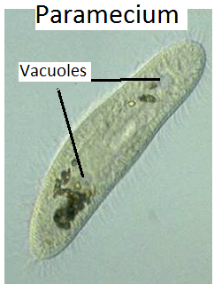 on the right is part of.

__________________________________________________________________

**3.** List the two types of blood cells in the body. (1 mark)

_____________________________________________________________________________________

**4.** Write two examples of a multicellular organisms you would find at the zoo. (1 mark)

_____________________________________________________________________________________

**5.** Look at the image below. What is the name of the process? (1 mark)

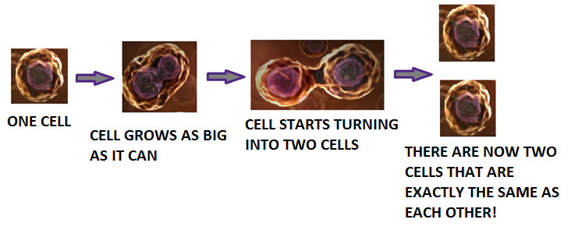

________________________________

**6.** Explain the difference between unicellular organisms and multicellular organisms. (2 marks)

_____________________________________________________________________________________

_____________________________________________________________________________________

_____________________________________________________________________________________

**7.** Explain why muscle cells have lots of mitochondria. (2 marks)

_____________________________________________________________________________________

_____________________________________________________________________________________

_____________________________________________________________________________________

**8. Fill in the missing words and label the diagram on the right.** (4 marks)

*Choose from the following words (some are used more than once): organs, cells, systems, tissues.*

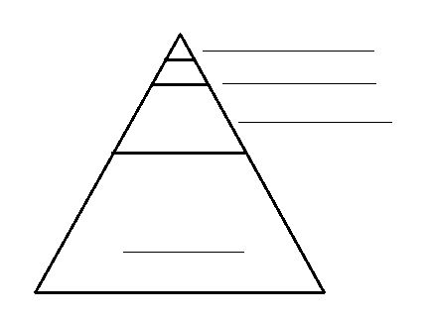

This diagram shows a pyramid where the bottom part represents ______________. There are many more cells in an organism than the number of __________________. There are more _________________ than there are organs, and there are more organs than there are the number of _________________.

**9.** List four places where epithelium is located on/in the human body. (4 marks)

_____________________________________________________________________________________

_____________________________________________________________________________________

_____________________________________________________________________________________

**10.** Circle either true or false for the following statements. (2 marks)

Many nerve cells grouped together are called nerve tissue. True False

Muscle tissue are not able to contract. True False

Tissues that add support and structure to the body are connective tissue. True False

Eggs in the female reproductive system are actually cells. True False

**11.** Fill in the missing words below. (2 marks)

Photosynthetic cells are near the surface of the green parts of stems and leaves in plants and have many organelles in them called ____________________, these are organelles that are only found in plant cells, not in _________________ cells.

The chloroplasts have a green chemical inside called _____________________ which traps the Sun’s energy and uses it to undergo the process of ________________________.

**12.** The picture below shows special cells found in plants that move water and food (1 mark)

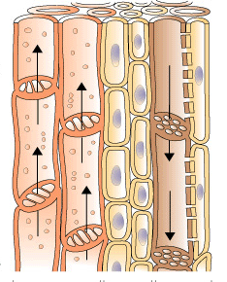 through plants. State the name given to these cells.

_______________________________________________________________

**13.** Write a description for ‘stomata’. (2 marks)

_____________________________________________________________________________________

_____________________________________________________________________________________

**14a.** State the name given to the type of cell below. (2 marks)

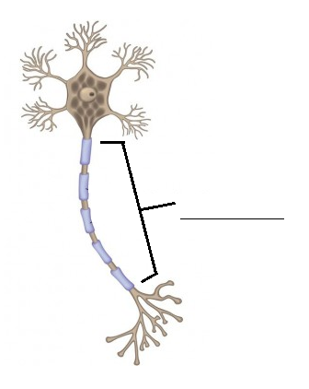

__________________________________________________________

**b.** Label the structure on the diagram of the cell to the right.

**15.** Fill in the table below. (8 marks)

|  |  |  |
| --- | --- | --- |
| Name of system | Description of system | Two examples of organs in  the system |
|  | Digests food. |  |
| Nervous system. |  |  |
|  |  | Ovaries, testes. |
|  | Gets oxygen from the air into the lungs and  gets rid of waste carbon dioxide. |  |
|  |  | Cartilage, bone. |
| Excretory system. |  |  |